How to Configure Modbus Data Module in iEMS PecStart

Description:
How to configure data module for the device that uses MODBUS protocol and the registers are provided? Take ION7650 as an example to show the brief steps.

Steps:
- Add a new site via SystemConfig. Select Driver Type to MODBUS-RTU or MODBUS-TCP/IP：
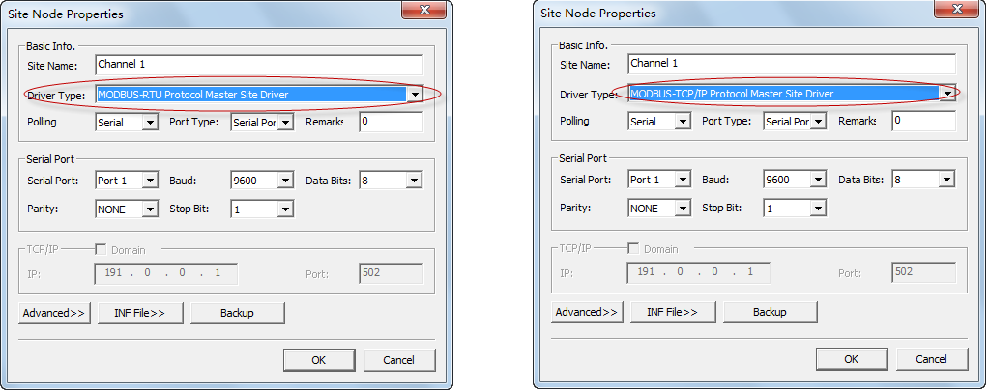
- Add a device under the site and select Type as ION7650：
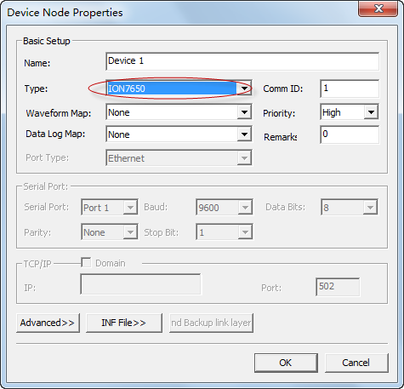
- Add an Analog Data Point:
- Select a device and click the 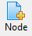 button.
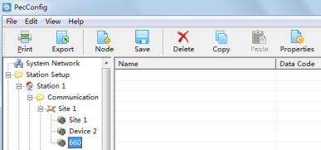
- Select Analog and click OK.
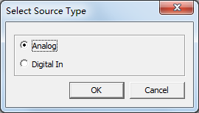
- Set properties for Analog Data Point.
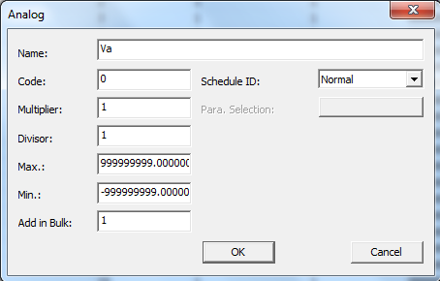

- Right-click and select Properties… and then click Appendix>>
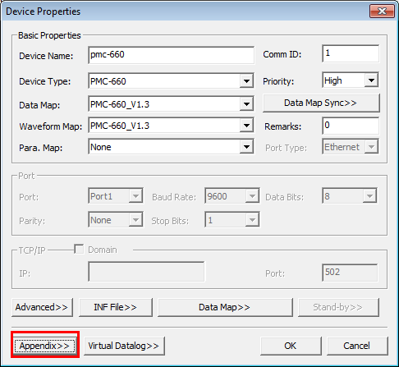
- Add data module by clicking Add a Block>> and Edit Modbus data module.
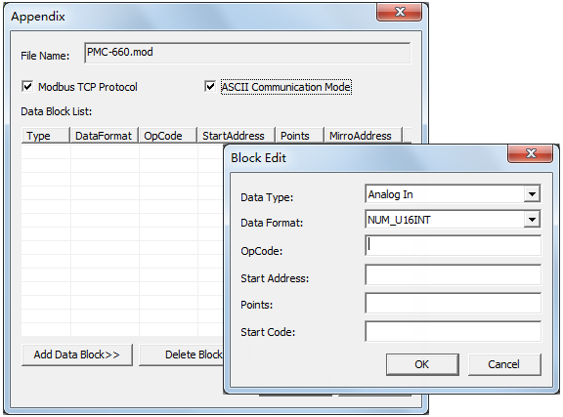
If it’s standard Modbus protocol, it’s not necessary to check the ModbusTCP Protocol box and ASCII Communication Mode box.
- Data Type: Data type of data module, for example, Analog In/Out, Digital In/Out.
- Data Format: Data format of data module, e.g.: NUM_U16IN (unsigned 16 integer), NUM_S16INT (signed 16 integer), NUM_U32IN (unsigned 32 integer), NUM_S32INT (signed 32 integer), NUM_U32MFP (MODBUS unsigned 32 float), NUM_S32MFP (MODBUS signed 32 float).
- OpCode: function code, for example, 03 Read Holding Registers.
- Start Address: register start address
- Points: number of data points
- Start Code: start number of data points
Example:
Read 4 Analog Ins for 03 function code and the start address is 4096, the corresponded parameter numbers in SystemConfig are 0~3. Similarly, reading 2 Digital In for 03 function code which start address is 40020 and the corresponded parameter numbers in SystemConfig are 0~1. This configuration can be changed flexible to control driver’s reading if the register address altered.

